The SMBX64 Level Map
It is probed by Wohlstand 02/12/2014
Introduction
Standart parameters:
Standart size of one block 32x32 pixels
On screen can showing height 19 blocks
On screen can showing width 25 blocks
Height of screen 608 pixels (non 600, 608: 608/19=32 — one block size)
Width of screen 800 pixels
Max level space size: 419998×419998 pixels (but It is allowed to come out of limits)

Limits of objects on one level map:
Blocks: 20000
NPCs: 5000
Background objects: 8000
Doors: 200

Level Map:
Each level map is divided into 21 sections, which can be created "room". All sections are located in the same level space. Levels are displayed on coordinates with the reflected Y.
Default section positions:

Level sections

The green squares – is a default zones of level sections:

The section size and position defining by position of eash side of section.
height and width are calculated on a formula:
W = |L-R| H = |T-B|
Sections can be have any size and position, but sections won't be crossed.

Examples:

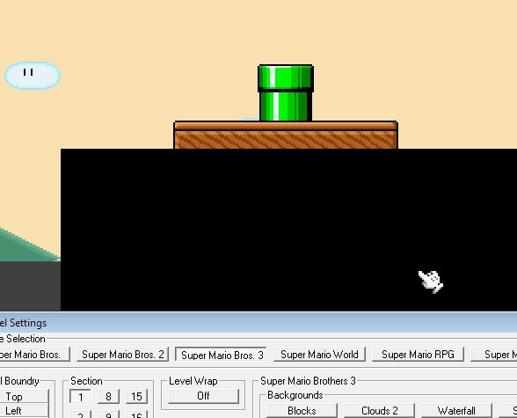
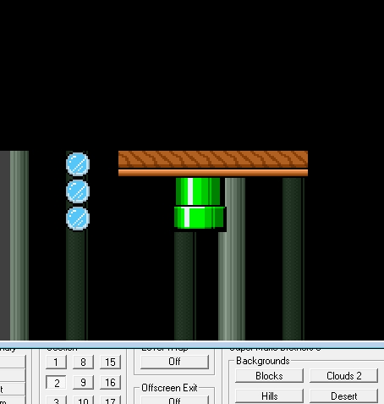
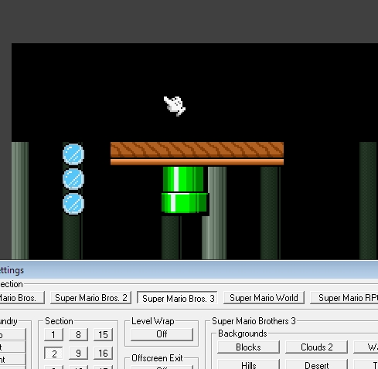
Consequences of inter-crossing of sections:
Default sections position

This is the default zones, used for creation of new section, if it is empty:

(Section Center) Section (X and Y axis ranges)
-200000 01 (-190000 : -219999)
-180000 02 (-170000 : -189999)
-160000 03 (-150000 : -189999)
-140000 04 (-130000 : -149999)
-120000 05 (-110000 : -129999)
-100000 06 (-90000 : -109999)
-80000 07 (-70000 : -89999)
-60000 08 (-50000 : -69999)
-40000 09 (-30000 : -49999)
-20000 10 (-10000 : -29999)
0000 11 (9999 : -9999)
20000 12 (10000 : 29999)
40000 13 (30000 : 49999)
-60000 14 (50000 : 69999)
80000 15 (70000 : 89999)
100000 16 (90000 : 109999)
120000 17 (100000 : 129999)
140000 18 (130000 : 149999)
160000 19 (150000 : 169999)
180000 20 (170000 : 189999)
200000 21 (190000 : 209999)

- Standart size of one section zone is 29999×29999 pixels
- Y is always equal to X as Section center coordinates
- where x=0 and y=0 – is a center of 11'th section.

For convert from absolute coordinates to the relative of center by one section:

Coordinates of placement of object it is set concerning its upper left corner:
In this example, mushroom coordinates on current section is: X=2150; Y=2600
and block coordinates is: X=2150; Y=2632

Remember!
As the Y axis is turned to move object down, it is necessary to add to Y offset and to move up, it is necessary to subtract.

